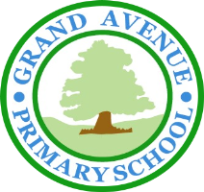
GRAND AVENUE PRIMARY AND NURSERY SCHOOL
BEHAVIOUR POLICY – DRAFTED AND AGREED BY MEMBERS OF THE SCHOOL COUNCIL

Why do we need to have agreed ‘expected behaviours’?

We think it is important for all of us to know what is expected of us when it comes to behaviour. If we did not show ‘expected behaviour’, we would not be able to learn or have a positive experience of our education. If children do not show these behaviours, it is possible that others would not be able to have fun at school, or be able to achieve their potential in any of their subjects.

Also if we do not have kind hands and feet, lots of children could get physically injured. However, if we do show helpful behaviour, we will live in a safer environment and everyone will be able to ‘Enjoy Learning – Exceed Expectations’.


What are the expected Behaviours at Grand Avenue Primary and Nursery School?

We are at Grand Avenue, so we follow the Grand Rules. These are to be:
Generous
I will be
helpful, polite and
considerate of others.

Respectful

I will use kind hands, feet and words.

Aspiring

I will be honest and tell the truth.

Neat

I will be quiet and sensible when lining up and walking around school.

Determined
I will try my best to do my work and not disturb others.

These rules help us all to ‘Enjoy Learning - Exceed Expectations’ as each of us can learn somewhere we feel safe.
We have lessons about these rules to help us to think about what they look like at different times and in different places in the school (and at home!).

What are unexpected behaviours?

When we do not follow the GRAND Learner Rules, we are showing ‘unexpected behaviours’. If we are unkind with our bodies or our words or if we do not think about how our behaviour is affecting others, we are not helping to create the environment where everyone can ‘Enjoy Learning – Exceed Expectations’. When we do not feel safe, it is hard for us to feel like we ‘belong’ here. Feeling like we belong – whoever we are - is very important for us to feel safe.

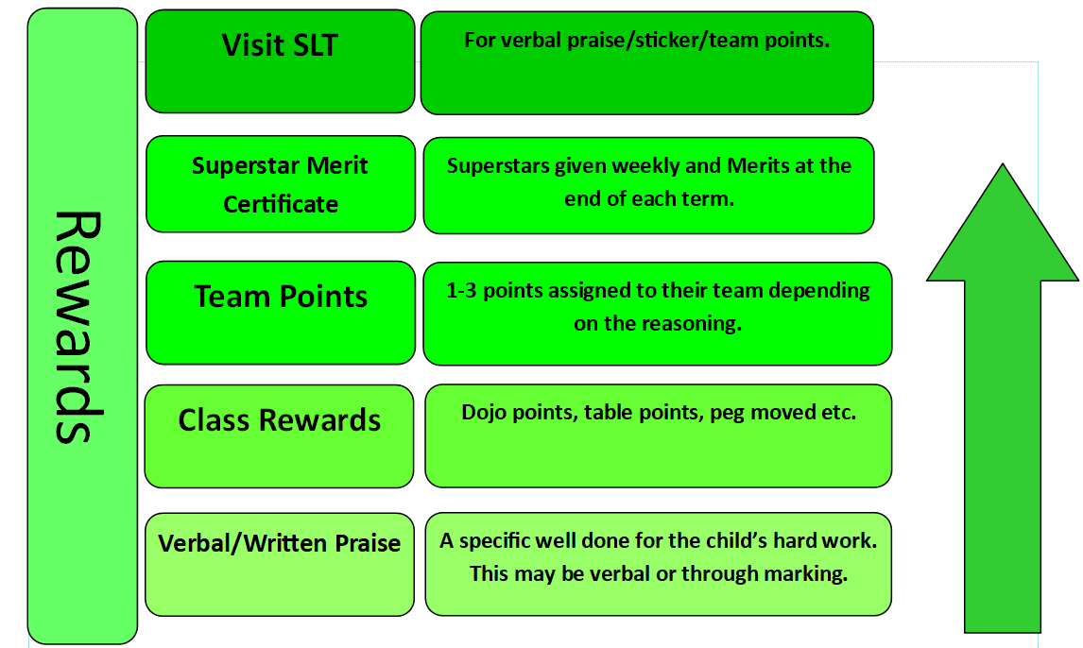
How are we encouraged to show expected behaviours?

We have a clear set of steps that will happen when we show that we are GRAND Learners and are being kind to others and ourselves. It starts with verbal praise but we can also earn a variety of rewards. These depend on the agreement in each class but could be: raffle tickets, Dojo Points, Team Points, stickers, extra free time, marble jars, cushions and positive feedback to our parents and carers. Overall, when we all show the same helpful behaviour that respects others, we all feel like we belong and want to be here.

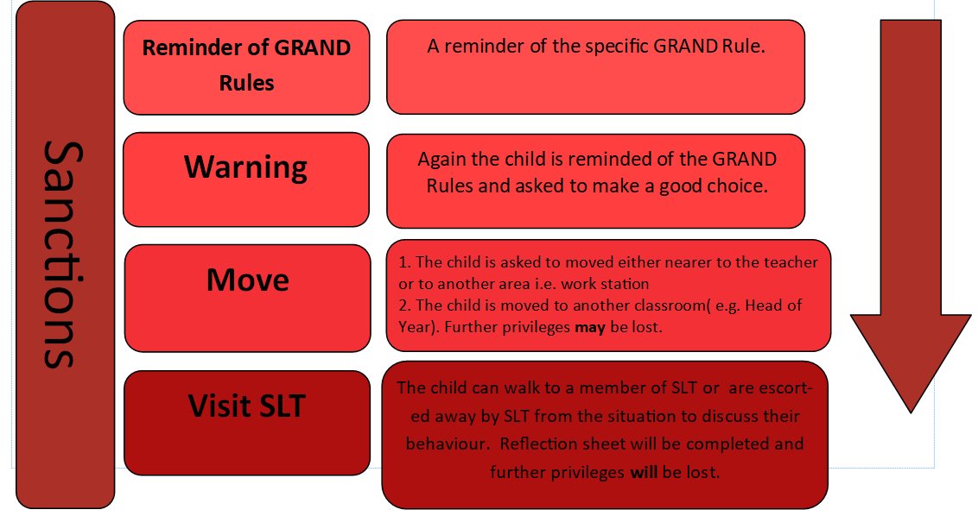
What are the consequences for unexpected behaviour?

It is important to know when we are showing helpful behaviour but it is just as important that we know when we are not. This means we know what the boundaries are and also helps us to feel safe. When we show ‘unexpected behaviours’, there is again a clear set of steps for the consequences for our actions or words. We get consequences such as missing break or going to a member of SLT, which are the head, deputy head or assistant head. Most importantly, when we have upset others, we are sure to make the perfect apology.
.

