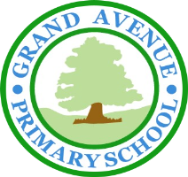
GRAND AVENUE PRIMARY AND NURSERY SCHOOL
BEHAVIOUR POLICY – DRAFTED AND AGREED BY MEMBERS OF THE SCHOOL COUNCIL

Why do we need rules for how we behave?
Because they help us be happy and safe at school!
If we don’t follow the rules, people can get hurt or feel sad and it’s harder to learn and have fun.

What are the good behaviours we should follow?

We are at Grand Avenue Primary and Nursery School, so we follow the Grand Rules. These are to be:
Generous
I will be
helpful, polite and
considerate of others.

Respectful

I will use kind hands, feet and words.

Aspiring

I will be honest and tell the truth.

Neat

I will be quiet and sensible when lining up and walking around school.

Determined
I will try my best to do my work and not disturb others.

These rules help us all to ‘Enjoy Learning - Exceed Expectations’ as each of us can learn somewhere we feel safe.
We talk about these rules in class and learn how to follow them everywhere—at school and at home!

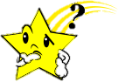
What happens when we don’t follow the rules?
That’s called unexpected behaviour - like being unkind with our words or hands, not listening, or stopping others from learning.
When that happens, we don’t feel safe or happy and others might feel the same too.

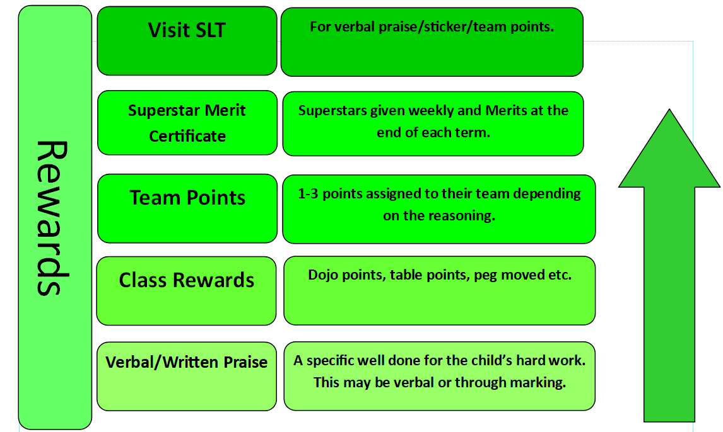
What happens when we follow the rules?
We get praise and fun rewards!
Some rewards might be:
- Stickers
- Team points
- Raffle tickets
- Free time
- Messages to your grown-ups saying
you did great!

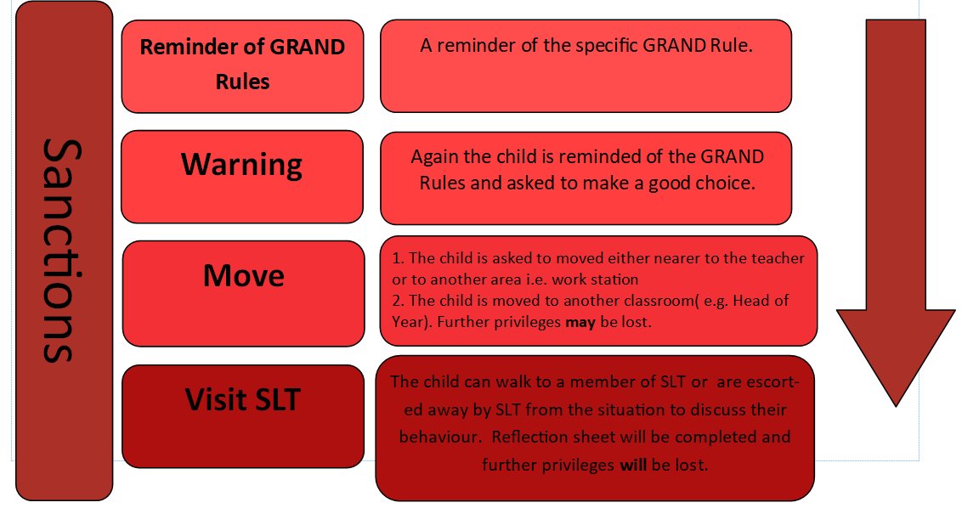
What happens if we don’t follow the rules?
There are clear steps that help us understand what went wrong.
We might miss playtime or talk to one of the Senior Leadership team.
If we hurt someone’s feelings, we always say sorry in a kind and thoughtful way.

Remember: When we follow the Grand Rules, everyone is happy, safe, and ready to enjoy learning!

